Acceptance Testing
UAT Execution&ReportSubmission
DATE | 10 FEB 2026
PROJECT ID | LTVIP2026TMID89249
PROJECT NAME | CIVIL ENGINEERING INSIGHT STUDIO
MARKS

- Purpose of Document: The purpose of this document is to briefly explain the test coverage and open issues of the [ProductName] project at the time of the release to User Acceptance Testing (UAT).

- Defect Analysis: This report shows the number of resolved or closed bugs at each severity level, and how they were resolved.
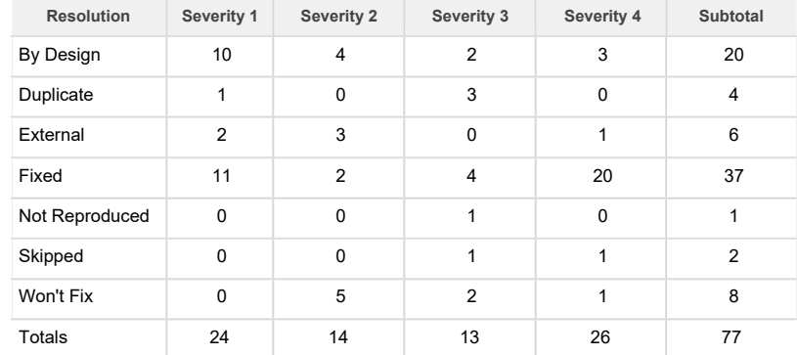

- Test Case Analysis: This report shows the number of test cases that have passed, failed, and untested Fail

